Bayesian Inference on Expected Returns and Volatility of First Day Returns IPOs vs. S&P 500

Spencer Allgaier

Hudson Downs

There have been countless individuals and companies, humans and robots, who have attempted to predict the returns on the stock market over the years in search of financial gain, albeit unsuccessful. Even if the individual stock values cannot be precisely predicted, assumptions on the average return for a homogenous group of stocks can be made with Bayesian statistics. An Initial Public Offering (IPO) is the first opportunity the public has to buy stock from a company and is particularly volatile in price, meaning that the variance is high and therefore similar across most IPOs, even being unknown. The average return for the first day of an IPO stock is also unknown which creates a high risk, high reward opportunity if the average return is positive. This model will compare the means and variances of two populations: first day return on IPO stocks in 2019 (%) and single day return of non-IPO stocks in 2019 (%). By using Bayesian methods to determine the mean and variance for the return on this specific class of stock, we can successfully create a plan to return consistent yields (based on the law of large numbers) on the short-term stock market.

**Problem of Interest:**

Random Variables:

$$Let X_{1}…X_{n} be n_{x} normally distributed random variables from a non IPO stock single$$

$$day return (\%)$$

$$Let Y_{1}… Y_{n} be n_{y} normally distributed random variables from an IPOfirst day return (\%)$$

Parameters:

$$d= μ_{y}-μ_{x} is the population difference between the average return for X and Y$$

$$g= {σ^{2}}_{y}-{σ^{2}}_{x} is the population difference between the average variance for X and Y$$

**Define the Model:**

Likelihood: $$Population X:f\left(x_{1}, …, x_{n_{y}}| μ_{x}, {σ^{2}}_{x}\right)=f\left({data}_{x} | μ_{x}, {σ^{2}}_{x}\right)$$

$$Population Y:f\left(y_{1}, …, y_{n_{y}}| μ_{y}, {σ^{2}}_{y}\right)=f\left({data}_{y} | μ_{y}, {σ^{2}}_{y}\right)$$

Prior Distribution:

$$μ_{x}\sim N\left(λ_{x},{τ^{2}}_{x}\right) and μ_{y}\sim N\left(λ_{y},{τ^{2}}_{y}\right) where λ_{y}= λ_{x}=0.027 and {τ^{2}}_{y}= {τ^{2}}_{x}=.5$$

$${σ^{2}}_{x}\sim IG\left(γ_{x},φ_{x}\right) and {σ^{2}}_{y}\sim IG\left(γ_{y},φ_{y}\right) where γ_{y}= γ_{x}=0.027 and φ_{y}= φ_{x}=.5$$

$$d\sim N\left(λ_{y}-λ_{x}, {τ^{2}}_{y}+ {τ^{2}}_{x}\right) where λ_{y}- λ_{x}=0 and {τ^{2}}_{y}+ {τ^{2}}_{x}=1$$

$$g\sim N\left({σ^{2}}_{y}-{σ^{2}}_{x}, \frac{{φ_{y}}^{2}}{(γ_{y}-1)^{2}(γ_{y}-2)}+ \frac{{φ_{x}}^{2}}{(γ_{x}-1)^{2}(γ_{x}-2)}\right)$$

$$where λ_{y}- λ_{x}=0 and \frac{{φ_{y}}^{2}}{(γ_{y}-1)^{2}(γ_{y}-2)}+ \frac{{φ_{x}}^{2}}{(γ_{x}-1)^{2}(γ_{x}-2)}=0.01458$$

The average return on the stock market historically has returned an average of about 10% annually (0.0027% daily), but year-to-year returns are highly variant, which is why we chose these prior parameters. The sample that we are using is specifically for the year 2019, so conclusions can only be made for the same population, the year 2019. The true average return value and volatility are unknown for these reasons.

Data collected for this analysis was gathered and randomly sampled from https://finance.yahoo.com/quote/ for returns on both IPO stocks and the S&P 500 (^GSPC) from January 1st, 2019 to November 19th, 2019. This particular index was chosen because of its historically high investment value. To prove the worth of returns on IPOs, this would be the best measure to compare against. The returns for each single day were calculated as a percent using this formula:

$$single day return=\frac{\left(day one open price-day two open price\right)}{day one open price}$$

Originally, the same day difference (open price – close price) was going to be used as our returns, but these returns for the S&P 500 turned out to be much less than the average daily return for the year. This is because a majority of the positive return for this specific index happened between trading hours as recorded by finance.yahoo.com. To adjust for this, we changed the returns to include returns between trading hours and this worked.

**Posterior Distribution**

Using Gibbs sampling we found estimates for the posterior distribution of μs and $σ^{2}$ s for both IPO stocks and the S&P 500 index. The following table contains the means and 95% credible intervals for μ and $σ^{2}$ for both IPO and the S&P 500:

|  |  |  |
| --- | --- | --- |
| Type of Stock | Mean of Parameter | 95% Credible Interval |
| IPO | E(μ) = 0.0305 | (0.0037, 0.0580) |
| E ${(σ}^{2}$)= 0.0266 | (0.0210, 0.0336) |
| S&P 500 | E(μ) = 0.0011 | (-0.0013, 0.0034) |
| E ${(σ}^{2}$)= 0.0003 | (0.0003, 0.004) |

We also found estimates for the posterior of the difference of μs and the posterior of the difference of $σ^{2}$ s. The following plots are our estimates:

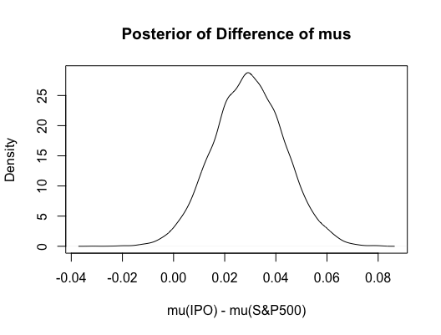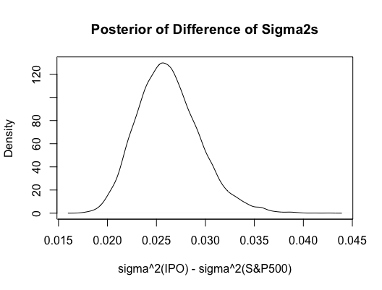

Our 95% credible interval for the difference of μs is 0.0023 and 0.0571 with an average difference of 0.0295. Since zero is not in this confidence interval, given our posterior distribution, the true expected return of IPO stocks is statistically higher than the true expected return of the S&P 500 index.

Our 95% credible interval for the difference of $σ^{2}$ is 0.0207 and 0.0333 with an average difference of 0.0262. There is a 100% chance that the true volatility of IPO stocks is greater than the true volatility of the S&P 500 index.

Our posterior distributions support the idea that IPO stocks are more profitable and riskier than the S&P 500 Index, but how often do IPO stocks give us better returns that the S&P 500? The following is our estimate for the posterior predictive distribution of the difference between the returns of IPO stocks and the S&P 500:

Using our posterior predictive distribution, we would expect around 57% of IPO stocks have higher daily returns than non-IPO stocks. This shows us that while the volatility is higher, as expected, the overall return is likely to be higher than even a high returning index in the long run.

